Become a ‘Friend’ of the

You too can become a ‘Friend’ of the Dunedin Youth Orchestra and help our talented young musicians achieve new heights in music performance.

The Dunedin Youth Orchestra has:
  - Established a successful formula for courses and weekend workshops;
  - Collaborated with other musical groups such as City Choir Dunedin and the Auckland Youth Orchestra;
  - Produced many top musicians;
  - Encouraged many to study and take up music professionally.

A suggested annual donation is $100.00 (tax deductible). For this you will receive information about the Dunedin Youth Orchestra events and a free ticket to the orchestra’s magical concerts. Please make your cheque payable to The Dunedin Youth Orchestra and post to:

The Secretary
Dunedin Youth Orchestra
48 Newport Street
Dunedin

We look forward to your continued support and thank you in anticipation.

–––––––––––––––––––––––––––––––––––––––––––––––––––––
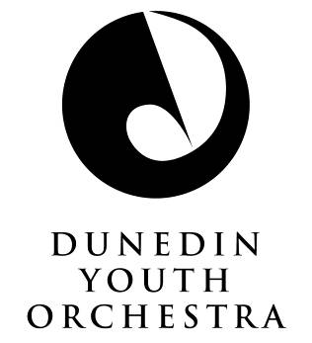
I hereby confirm that I wish to become a ‘Friend’ of the Dunedin Youth Orchestra and enclose my cheque for $100.00 payable to The Dunedin Youth Orchestra.

Name:
Address:
Email:

